

**Lesson Plan**



**Emotional Intelligence**

***8 April 2025***

Table of Contents

About the Lesson 3

Before the Lesson 4

Presenting the Lesson 5

Appendix: Required Materials and Handouts 14

**How to Use this Lesson Plan**

This lesson plan is divided into three key sections and an appendix containing supporting material.

The **About the Lesson** section outlines the lesson and identifies requirements for its effective use. Course Directors should use this section to (a) understand the purpose and context of the lesson, (b) learn about lesson pre-requisites, and (c) guide the selection of facilitators.

The **Before the Lesson** section provides details on the preparation required for this lesson, including participant prerequisites (if any), recommended facilitator pre-course readings, and guidance on how to prepare the classroom.

The **Presenting the Lesson** section contains the actual lesson plan. It provides the recommended outline, discussion, and slide prompts along with actual *questions* and *recommended language* for the facilitator to use in the classroom.

The **Appendix** includes any required in-class handouts or exercise material.

For more information on how lessons are structured, or how to use them in the course, see the ***Course Director’s Handbook*** or ***Facilitator’s Resources***.

**Contact Us**

Email: [flightcommandersedge@us.af.mil](mailto:flightcommandersedge@us.af.mil)

Website: <https://www.airuniversity.af.edu/GCPME/Flight-Commanders-Edge/>

# About the Lesson

**Emotional Intelligence**

## Overview

This lesson describes the link between emotional intelligence skills and leadership. It introduces flight commanders to the essential emotional intelligence skills that matter most for success in their flights. Participants are first exposed to the role of emotions in leadership. Following this, different elements of emotional intelligence are examined. Finally, an activity will outline methods to improve the four commonly used emotional intelligence skills.

## Objectives

By the end of this lesson, participants will be able to:

1. Identify the role of emotions in leadership.
2. Describe the four key skills of emotional intelligence.
3. Outline methods to improve emotional intelligence behaviors.

## Recommended Prerequisites

* None

## Recommended Time

* 50 minutes

## Recommended Facilitator Qualifications

This lesson is designed for a facilitator with the following minimum qualifications:

1. Subject matter knowledge
2. Command-level experience

Note: Subject matter knowledge can be developed using the information presented in **Preparing the Facilitator** section of this document.

# Before the Lesson

## Preparing the Participant

* None.

## Preparing the Facilitator

All participant preparation, plus:

* Be familiar with the TEDx video by Dr. Travis Bradberry
  + <https://www.youtube.com/watch?v=auXNnTmhHsk>

(Optional) Additional deep-dive preparation materials are available on *The Flight Commander’s Edge* website.

## Preparing the Classroom

* Adequate classroom space for separate small group discussions.
* White boards or easels with butcher block paper (one per group).
* Computer and projector with internet connectivity (and Youtube.com access if use Option B, see page 10 for link)

## Preparing Required Materials

Prepare one copy of each handout below for each participant. Do not distribute handouts before the class.

* Global College of PME, *Enhancing Your Emotional Intelligence Skills Worksheet*
* Global College of PME, *Self-Assessment Worksheet*

Handouts are available in the Appendix.

# Presenting the Lesson

***NOTE:*** *This lesson is designed for up to five (5) groups of participants. Groups should be no larger than five (5) members to maximize participation during small group discussion.*

## Introduction (5 minutes)

The introduction to the lesson sets the stage for future learning through a group discussion on the role of emotions in leadership.

### Slide 1: Emotional Intelligence

Introduce the lesson.

**To be an effective flight commander and leader you need to know yourself, how you interact with others, and how others perceive you. Perhaps one of the hardest things flight commanders will do is to see themselves as others see them.**

### Slide 2: Objectives

This slide lists the lesson objectives.

After participants have reviewed the lesson objectives, continue.

### Slide 3: Quick Poll

Continue the presentation.

**Let’s take a quick poll.**

**How many of you have heard the term *emotional intelligence*? (Just raise your hands.)**

**Ok, here is another question.**

**How many of you have a positive impression of emotional intelligence?**

**A negative impression?**

**Anticipated Responses:** Vary. This activity is used as an intro to the content below.

### Slide 4: Small Group Discussion

Divide the class into small groups (4 or 5 members), and prompt the participants with the following statement:

**Let’s begin the lesson with a discussion in your small groups. Consider the following questions:**

**Are emotions important aspects of leadership?**

Focus groups on providing examples of emotions observed or experienced, not complaining about emotional outbursts.

**Why?**

**Take about five (5) minutes and share your thoughts. In a few minutes, we will return and discuss your findings with the larger group.**

Monitor discussions for activity.

After five (5) minutes, continue.

## Initial Discussion (10 minutes)

The initial discussion continues the introduction activity. Participants will summarize their discussions and self-discover the importance of emotions in leadership.

### Slide 5: Large Group Discussion

Reconvene the large group and ask one member from each small group to share an example from their group’s conversation.

**What did you learn?**

**Are emotions important aspects of leadership?**

**Why?**

**Anticipated Responses:** Vary but should focus on the following.

Emotionally self-aware leaders:

* Are not afraid of the emotions of others.
* Share more freely with others create a more efficient workplace (learning/growth environment).
* Can focus on maximizing strengths and mitigating weaknesses in relationships with others.
* Encourage trust through authenticity and respect.
* Are approachable.
* Display confidence (they are not easily overwhelmed).
* Make quality decisions based on accumulated wisdom and understanding.

After a brief discussion, continue.

**Based on your responses, it is evident that we all agree -- emotions play a role in leadership.**

**The real question is this: How can we recognize and understand emotions in ourselves and others, and use this awareness to manage behavior and relationships?**

**The study of this skill is called emotional intelligence.**

### Slide 6: Emotional Intelligence

Continue the presentation.

**When the Professional Military Education school began teaching the topic of emotional intelligence in the mid-2000s, they found that before even knowing what emotional intelligence was, many people discounted the idea. Even today, many continue to do discount it for lots of reasons:**

* **They think it is based on social – fuzzy – science.**
* **They believe it is unmeasurable.**
* **They think showing emotions is a sign of weakness.**

**Fortunately, all of these reasons are wrong.**

**Emotional intelligence is about awareness of key skills and behaviors that, as we’ve already discussed, are critical to leadership.**

**The official definition, from two of the leading EI researchers, is shown on the slide.**

**There is now over 30 years of science documenting how emotions are critical to success in just about every endeavor.**

**Emotional Intelligence is important to you as a leader.**

## Content Presentation (5 minutes)

This section of the lesson examines emotional intelligence and identifies four key skills that emotionally intelligent leaders display and actively develop. Facilitators choose one of two options for presenting the content on Slide 7.

### Slide 7: The Four Skills of Emotional Intelligence

Continue the presentation.

**This chart basically represents the 30 years of science referenced above.**

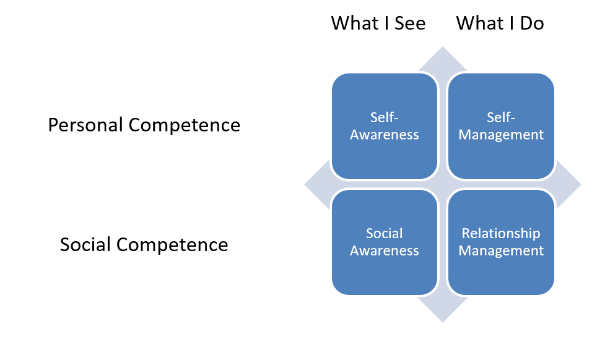

**OPTION A:** Facilitator reviews the slide with the class using the statements below.

**Instructor Note:**  Go through the statements below slowly. Allow participants time to digest the information contained in each statement before continuing.

**There are four key skills associated with emotional intelligence, and these skills are found in the blue boxes on the slide.**

**Emotional intelligence is all about understanding the emotions that drive our relationships. Please refer to the chart – the connections are relatively straightforward and hopefully easy to understand.**

**If you are self-aware, you understand yourself -- your motivations, your behaviors, and the reasons behind them.**

**If you understand yourself, you can improve your behaviors (shown here as self-management).**

**When you do this, you improve your personal competence.**

**As you improve your own personal competence, you become more aware of emotions in others. This is called social awareness.**

**When you are more socially aware, you can better handle difficult situations with others and more effectively manage your relationships to be positive and productive.**

**That’s it.**

**Fortunately, you don’t need to memorize all of this. All you need to do is work on improving these four specific skills.**

**OPTION B:** Facilitator shows an animation infographic (video) by Brendon Gouveia from You Tube (<https://www.youtube.com/watch?v=weuLejJdUu0>) which outlines Emotional Intelligence.

**Instructor Note:**  Have Slide #7 up before and after the video. The video takes approximately 3 minutes to play. After the video allow participants time to digest the information contained in the video. Prompt them with the following:

**The animation infographic used similar terms to these on the slide. The four simple aspects the video used to describe emotional intelligence are**

**Perceive, Understand, Facilitate, and Manage.**

**Do you see how those terms correlate with the four specific skills on the slide?**

**Instructor Note:** Class should have quick discussion on similarities and/or differences.

When complete, continue.

**Fortunately, by thinking how the terms presented in the video match up to the specific skills on this slide, you are already beginning to work on improving your emotions skills.**

## Application Activity (25 minutes)

In this part of the lesson, participants use a group brainstorming approach to identify ways to improve emotional intelligence behaviors in the four key skill areas.

**Interesting Note:**  Anatomically the last part of the brain to mature is the area of executive functions, so older participants may offer different perspectives than younger ones.

Prepare the classroom by setting up four (4) easels with butcher paper (or four separate white boards) with the for key emotional intelligence skills.

*Self-Awareness*

*Self-Management*

*Social Awareness*

*Relationship Management*

When complete, continue.

### Slide 8: Enhancing Your Emotional Intelligence

Introduce the exercise

**Improving your abilities in the four emotional intelligence skills can pay huge dividends.**

**But, how do we improve?**

**It is possible to teach a lengthy course on each of these skills, but we – as commanders – don’t have that kind of time. What we do have is time for micro (small) adjustments in our behaviors.**

**You just need to know what to focus on.**

Distribute, **Global College of PME, Enhancing Your Emotional Intelligence Skills Worksheet**.

When complete, continue.

**Instructor Note:** This exercise is designed for four groups. If you have more than four groups, recombine as required.

Begin the exercise

**Around the room are written the four emotional intelligence skills.**

**I’d like each group take to pick [an easel / whiteboard] and go up to it. Take your worksheet.**

**When I begin the clock, take a moment to identify the key behaviors on the worksheet for your selected skill. Then, over the next few minutes, brainstorm two things:**

* **Other behaviors that can contribute to this skill, and/or**
* **Methods to improve on the behaviors listed.**

**Write your ideas on the [easel / board].**

**After five (5) minutes, rotate. We will repeat this until each group has had a turn at each of the boards. This will leave a five minute “final out brief” period at the end.**

Begin the exercise and monitor for time. Do not let the groups go longer than five (5) minutes.

After all rotations are complete, continue.

Take a few minutes (no more than 5 minutes total) to summarize the suggested methods to improve. Ask clarification questions of the groups if required. Remind participants to record tips and ideas they may want to explore or apply in the future on the handout.

## Lesson Wrap-Up (5 minutes)

The final lesson activity is a self-assessment of effective communication behaviors. This activity feeds the final lesson in the course – *The Road Ahead* – and will be used to support the development of the participants’ personal development plan.

Distribute the **Global College of PME, *Emotional Intelligence Self-Assessment Worksheet*** to all participants.

When complete, continue.

### Slide 9: Self-Assessment

Initiate the self-assessment and wrap up the lesson.

**It is very easy in our digital world to have less and less face-to-face interactions and to hide our emotions behind the warm glow of a computer monitor or phone screen. Yet emotions are still there, and you must be aware of them.**

**To be effective, leaders must have a solid understanding of how their emotions and actions affect the people around them. The better a leader relates to and works with others, the more successful he or she will be.**

**The *Emotional Intelligence Self-Assessment Worksheet* is designed to help you plan for your future. The instructions are self-explanatory. Take a moment to read them, then fill out the sheet. If you need more time, you can go into the break.**

**Keep this worksheet for reference. You will need it again for the last lesson of the course.**

End. Break (10 minutes).

# Appendix: Required Materials and Handouts

The materials required for this lesson include:

* Global College of PME, *Enhancing Your Emotional Intelligence Skills Worksheet*
* Global College of PME, *Emotional Intelligence Self-Assessment Worksheet*

These handouts, on the following pages, are designed for printing directly from the lesson plan. Ensure you print enough copies for all class participants.

## Enhancing Your Emotional Intelligence Skills Worksheet

*Developed by the Global College of PME*

|  |  |  |
| --- | --- | --- |
| **Skills** | **Behaviors** | **Brainstormed Ideas to Improve** |
| **Self-**  **Awareness** | **Learn about yourself**   * Recognize your own emotions and how they affect your thoughts and behaviors * Learn your strengths and weaknesses * Control your reactions by developing an awareness of how you respond in various situations |  |
| **Self-Management** | **Manage your emotions**   * Watch for impulsive feelings and behaviors * Manage emotions in healthy ways * Take the initiative * Build relationships * Follow through on commitments * Adapt to changing circumstances |  |
| **Social Awareness** | **Be aware of the emotions of others**   * Understand the emotions, needs and concerns of others * Be friendly and polite; build rapport * Watch body language * Use open-ended questions * Create emotional connections * Practice empathy |  |
| **Relationship Management** | **Ease into more productive / positive relationship behavior**   * Maintain good relationships * Manage conflict * Develop team-building skills |  |

Adapted from Bradberry, T., & Greaves, J. (2009). *Emotional Intelligence 2.0.* San Diego, CA: TalentSmart.

## Emotional Intelligence Self-Assessment Worksheet

This self-assessment provides an opportunity for you to assess your own leadership skills and behaviors. These skills and behaviors are based upon the concepts addressed within this lesson. *You will use these worksheets again during the final lesson of the course.*

**NOTE:** You may have identified other behaviors during the group exercise. If so, consider adding those behaviors to the assessment in the space provided.

Rate yourself on a scale of 1-5 in each of the skill or behavior areas below:

5 – Needs No Improvement 3 – Average 1 – Needs Significant Improvement

| Competency | Skill | Behavior | Self-Assessment  (1-5) |
| --- | --- | --- | --- |
| Leading People | Self-Awareness | **Learn about yourself**   * Recognize your own emotions and how they affect your thoughts and behaviors * Learn your strengths and weaknesses   Control your reactions by developing an awareness of how you respond in various situations   * __________________________ * __________________________ |  |
| Leading People | Self-Management | **Manage your emotions**   * Watch for impulsive feelings and behaviors * Manage emotions in healthy ways * Take the initiative * Build relationships * Follow through on commitments * Adapt to changing circumstances * __________________________ * __________________________ |  |
| Leading People | Social Awareness | **Be aware of the emotions of others**   * Understand the emotions, needs and concerns of others * Be friendly and polite; build rapport * Watch body language * Use open-ended questions * Create emotional connections * Practice empathy * __________________________ * __________________________ |  |
| Leading People | Relationship Management | **Ease into more productive / positive relationship behavior**   * Maintain good relationships * Manage conflict * Develop team-building skills * __________________________ * __________________________ |  |

Some tips:

* Ask your supervisors, peers, and subordinates how they perceive your behaviors in these areas. Often, we are biased toward ourselves, meaning we tend to rate ourselves better than others actually perceive us. In leadership we must strive to minimize the differential between how *we think we behave* and *how others perceive* our behaviors.

| My Notes |
| --- |
|  |